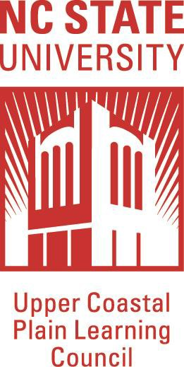
2019 Wilson Engineering Camps
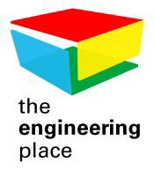
Elementary and Middle School Camps
June 17—21, 2019

LOCATION: Wilson Community College
Teacher Application
The NC State College of Engineering/The Engineering Place in partnership with Wilson Community College and the Upper Coastal Plain Learning Council will be offering week-long, non-residential summer day camps for elementary and middle school students. The camps will be led by area staff in collaboration with The Engineering Place from NC State University.

Opportunity Overview for Engineering Summer Programs Teacher Team Leader

We are very pleased to offer this opportunity for elementary, middle, high school teachers and post-secondary instructors. The opportunity involves working with a team of approximately 12 students to help them solve real-world challenges presented in the field of engineering.

Applicants should have a science, math or technical education background or be interested in learning how to use engineering to help make academic connections in their classrooms. Candidates should be highly motivated and enthusiastic individuals who are interested in hands-on activities. In addition, these teachers should be interested in learning about ways to integrate STEM into their classroom instruction.

We are not limiting teachers to selecting camps based solely on the grade levels they currently teach.

Stipend rates are $1000 for teachers and $600 for teacher assistants for the week which covers the time spent in the camps and in training. Daily camp hours run approximately 8:00 am until 4:00 pm. Additional time may be required before and after the daily camp sessions.

Required Training Dates

- Regional NCSU Teacher Training: Saturday, May 4 (8:30 a.m.–4:00 p.m.) at Daniels Hall on the campus of NC State University. Lunch will be provided.
- Wilson Engineering Staff Camp Prep: Saturday, May 18, 2019 (8:30 a.m.–4:00 p.m.) and Saturday, June 15, 2019 (9:00 a.m.-4:00 p.m.) at Wilson Community College Eagles Business Center. Lunch will be provided.

Additional Questions
Contact Dr. Kathy Lawson (252-813-7510) or Betty Jones (252-813-8934)

TEACHER APPLICATION

Applications must be received by April 12, 2019.
Notification of employment will be sent by April 19, 2019.
Date

Name_

Address_

Daytime Telephone_ Cell Phone

Email Address

Gender: Female / Male (circle one)

Which group of campers would you prefer working with (elementary or middle) and what qualifies you to work with that age group?

Why would you like to be part of the Wilson Engineering Camp 2019?

I will be available to attend regional in-service training at NC State University on Saturday, May 4th, 2019. I will also be present for pre-camp meetings and in-service training at Wilson Community College on the dates specified.

YES_
NO
Page 1 of 2

School Name:

School District:_

Years of teaching experience:

Current grade level:_
Years at Current Assignment:

Principal's Name:_

Principal's phone number:

In this space, please provide any other relevant information you think would help us determine your qualifications to teach at the summer Engineering Camps:

Signature
Date ___________

(I attest that all information provided is true and correct.)

Please mail or email application to:
Betty Jones, Community Outreach Specialist
Upper Coastal Plain Learning Council/NCSU
PO Box 7989
Rocky Mount, NC 27804
bnjones5@ncsu.edu

Page 2 of 2

